The Five Prime Motivators

Understanding What Attracts and Motivates Candidates

NLE Coaches Guide



Industry Experts | Innovative Practices | Global Perspective

The Five Prime Motivators

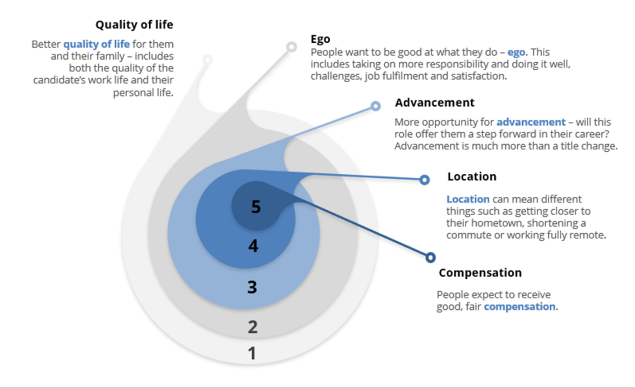

What Attracts Candidates?
What attracts candidates to new opportunities? What motivates them? Let’s take a moment and peak inside their minds. What compels someone to consider making a move to a different organization? It is easy to think, oh more money, but I can assure you that it is more complex than that. Additionally, if your candidate is solely focused on money – if that is their main or only motivation – that spells trouble with a capital T.
If you research the top 5-10 reasons why people change jobs you will find that rarely is salary listed as the number one reason people leave their current role. Keep that in mind when your candidate tells you they “just want more money”. That is rarely the true motivating factor.

So, let’s get inside our candidate’s psyche. Recruiters are not only sales professionals, we’re also unofficial psychologists, so let’s seek to understand what attracts people to a new opportunity. In general, there are five things a person is thinking about when considering a new opportunity for the first time. We call those the PRIME MOTIVATORS.
Quality of Life
Better quality of life for them and their family includes both the quality of the candidate’s work life and their personal life. When you consider “quality of life,” think about things such as how the company culture or the boss factor in. For example, is this a company and a boss that truly believes in work life balance, or is the employee expected to respond to emails and texts long after the close of their traditional workday?

Ego
People want to be “good” at what they do. This often means getting more responsibility in relation to their current position. It could also equate to new challenges, such as the size or scope of projects assigned. Ego is also all about fulfilment and job satisfaction. People want to be in a job they feel confident performing and they want to feel gratified by their work. They also want to know that others are taking notice and are grateful for their contributions.

Opportunity
More opportunity for advancement in the future is also important for many candidates. Is this position going to offer them a step forward in their career? It doesn’t necessarily mean that their title must change, but will they be adding skills that will make them more marketable in the future? Will their skill set advance and be enhanced? Opportunity for advancement is all about the role itself.

Location
This can be a chance to get closer to their hometown or their current residence such as shortening a commute by 20 miles or going “home” to Atlanta because Mom and Dad are getting older. It could also mean working fully remote or more of a hybrid scenario.

Compensation
People expect to receive good, fair compensation. Here is something else to consider. When a person first hears about an opportunity, they tend to assume they will make more money if they switch jobs. However, there is no rule that says just because you change positions or companies you automatically get more money. It is a common misperception.

In your career as a recruiter, you will move people for less money, the same, also known as a lateral move, or a heck of a lot more and every dollar amount in between. Now if someone is 100% focused on the money, we’ve got a different issue to deal with. For the rest, compensation gets pushed to the bottom of their priority list at first.

So, it is important to sell the “opportunity” first. Tell them everything else this potential change can offer. Explain all the other motivating factors and then money comes into play last.
Now recognize that when it comes time for a candidate to receive an offer, money is going to move to the top of the list not because it is suddenly most important but because it is the only “objective” thing they can qualify. If they are making $110,000 currently and the new offer is $120,000; they can clearly see that they will be getting ahead financially.

Keep in mind the non-monetary reasons that people take jobs and then the money is the tie breaker at the end. When people start considering a new opportunity, they have a hope and an expectation that it will pay appropriately. Therefore, money is not the main driver or attractor because they assume it will be there, but it can be a tie breaker at the end.

When attracting candidates, always lead with non-monetary things first. Get them emotionally invested in the opportunity. It makes the money conversation much smoother.
With the other four prime motivators, they can only assume that the new opportunity will improve those areas. It’s subjective and yet to be proven. Therefore, throughout the entire recruiting cycle you must keep reinforcing the prime motivators!

